**FAQs – Easy read**

**How long will it take for me to fill out the online form?**

**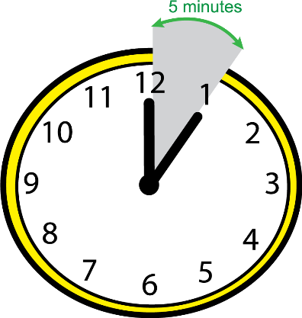***It should take less than five minutes, although it may take longer if you provide lots of information. The online form is one short page.*

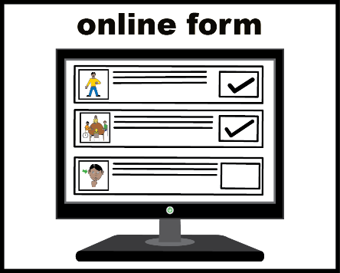

**Should I fill out the form?**

*You can fill out this form if you have witnessed (seen or heard) someone do something unkind to a resident of a care home for disabled adults who have:*

*- dementia (difficulties remembering things)*

*- learning disabilities*

*- brain injuries*

*You can fill in this form if what you witnessed made you feel uncomfortable (for example, it made you feel sad, angry, frightened or worried) or if you thought what you had witnessed might be mistreatment.*

**What does the word mistreatment mean?**

*Mistreatment is a word for all types of behaviour (things people do) that might be abuse or neglect. It can include violence, not allowing people to make decisions about their lives, bullying people and making them feel ashamed or embarrassed.*

**I don’t know if I have witnessed any mistreatment, can I still take part?**

*Yes, please still fill in the online form. If there is anything in particular you are unsure about you can write your question on the form.*

**Will I be contacted again, after I have filled out the online form?**

*Some people who fill in the form will be contacted by Josephine Sirotkin so that she can ask a few more questions. Josephine is the person running the research project. Not everyone who fills in the form will be contacted. You don’t have to talk to Josephine. It will always be your decision and your choice.*

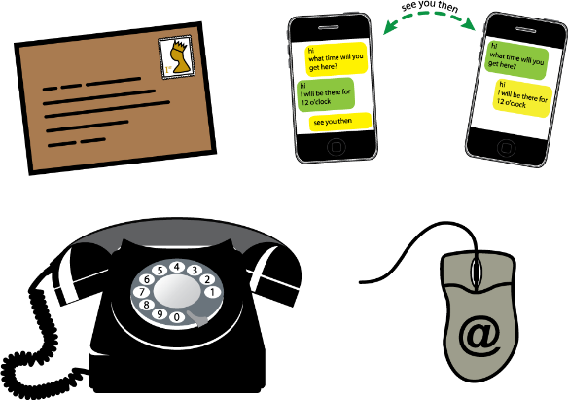

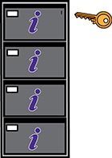**What will happen to the information I give on the online form?**

*Your contact details will only be seen by Josephine Sirotkin. No-one other than Josephine will know that it was you who filled in the form. Information about you will be kept very safely. Things you say in your answers may be ‘quoted’ in the thesis (book) Josephine will write. Your name will never appear next to anything you say, so you will remain ‘anonymous’.*

**I have a question or worry that is not answered here**

*Please contact Josephine Sirotkin, the primary researcher on this project. Her email is:*

*j.sirotkin@leeds.ac.uk*